**Developer Test Exam**

The database contains one table [Account] and has the following structure and data:

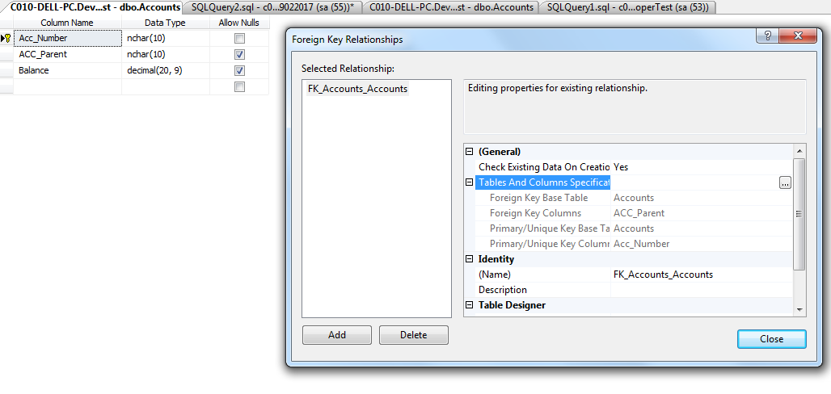

ACC_Parent is a foreign key column referencing ACC_number , represents parent and child account, the structure of the data being as the following:

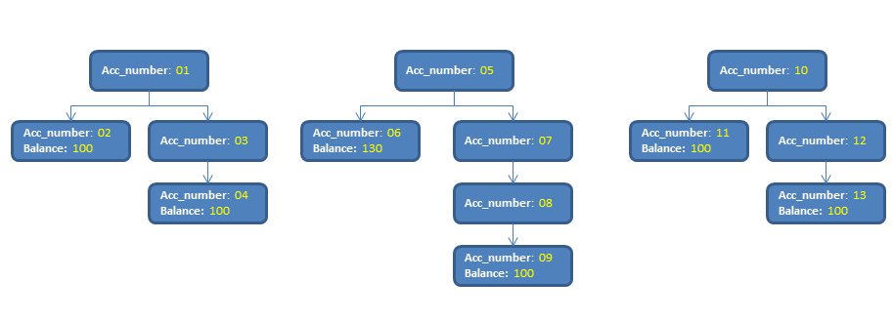

Using this data, develop the following solution Entity Framework, Dev Express and Ajax

1. Show the following Result for top level accounts using **one method** where total balance = sum of all balance for last accounts in the hierarchy tree:

|  |  |
| --- | --- |
| Top Level Account | Total Balance |
| 01 | 200 |
| 05 | 230 |
| 10 | 200 |

1. On the client side when user double click on a row, make an ajax call to a web API in to return the details of the sum, then show it as java script message as the following(lists the details of 01 account):

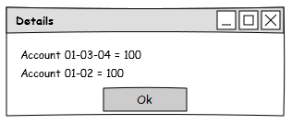

**Instructions:**

1. The database already exists with the data on the local server(SQL 2008 r2) and its name is TestDev. The password for [sa] account is [Thank$123]
2. You should connect to the database using Entity Framework
3. The solution must be developed using ASP. NET Core Web API and Ajax